21.Implement a C Program for an Array to sort in ascending order

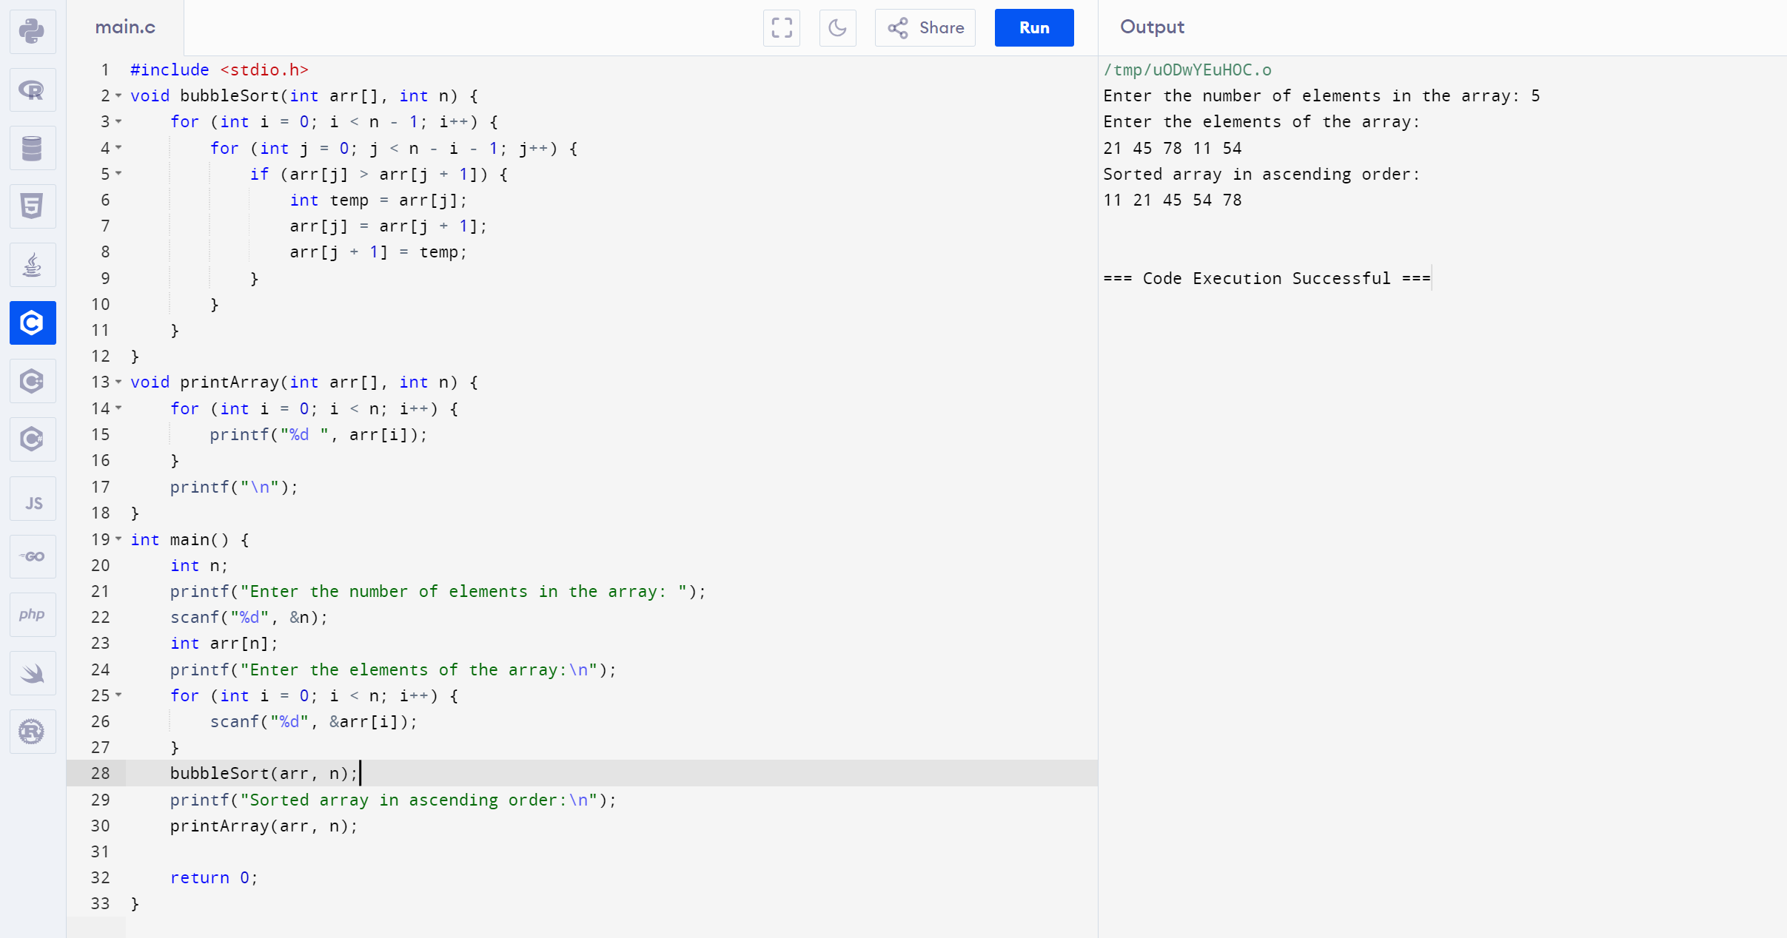

22. Implement a C Program to Print no of nodes in the given linked list

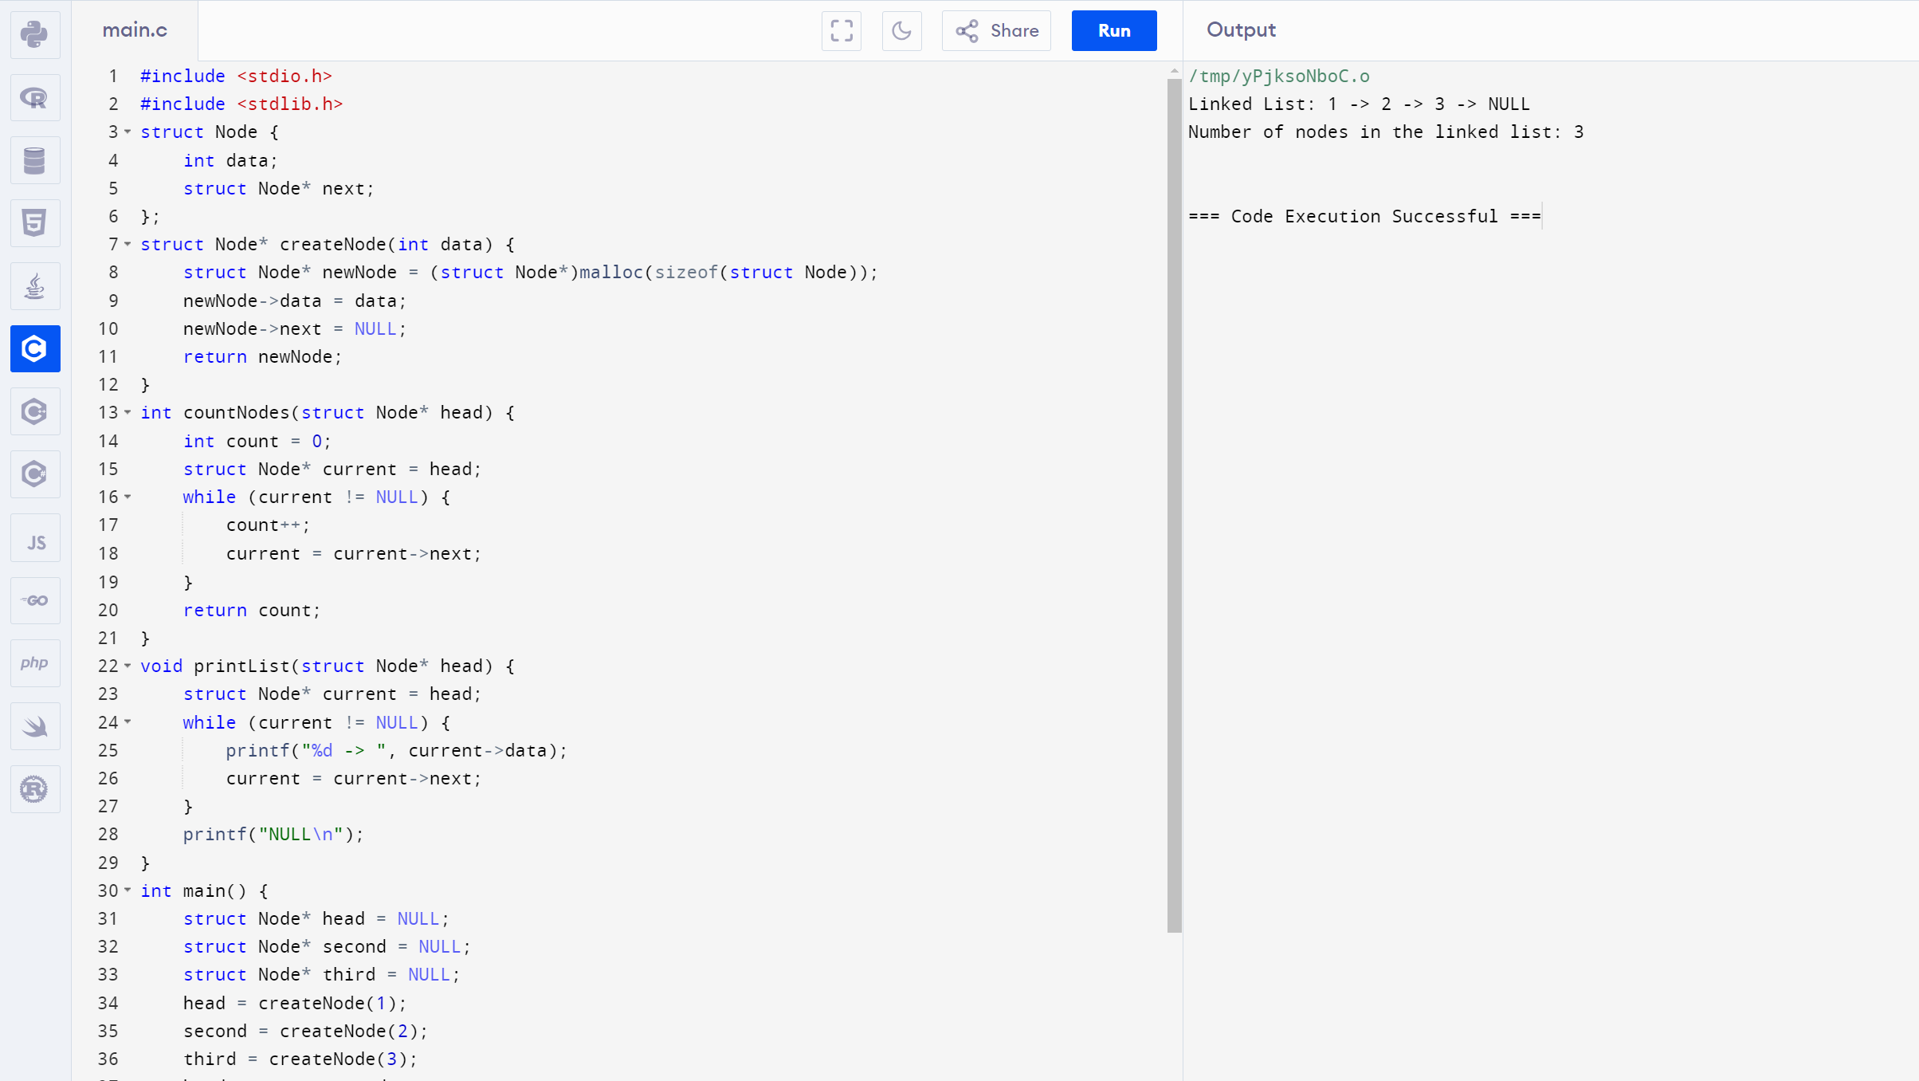

23. A Implement a C Program to perform search for sorted elements

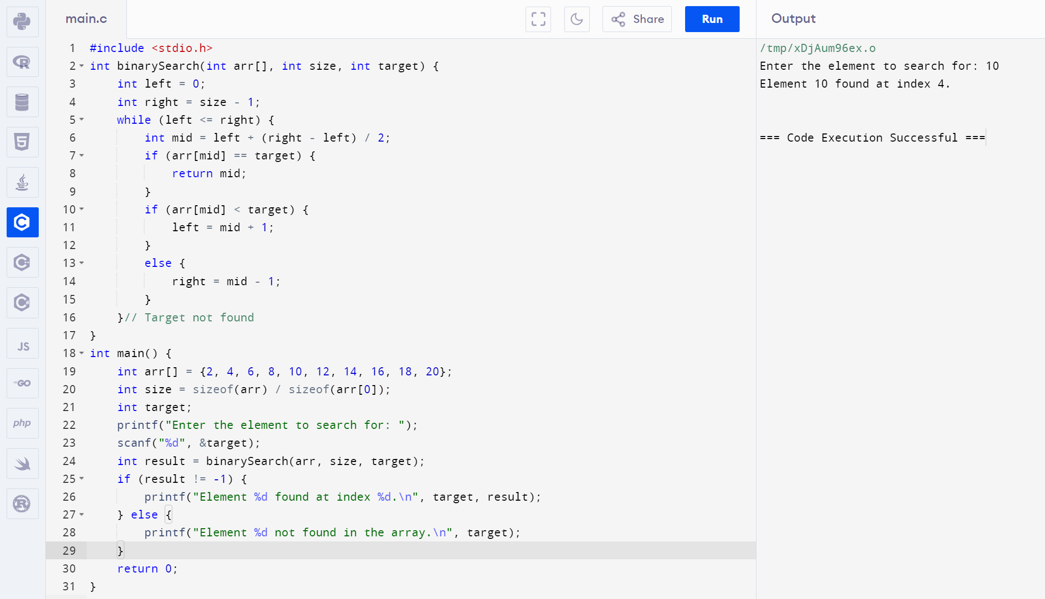

24. Implement a C Program to Print the index of repeated characters given in an array

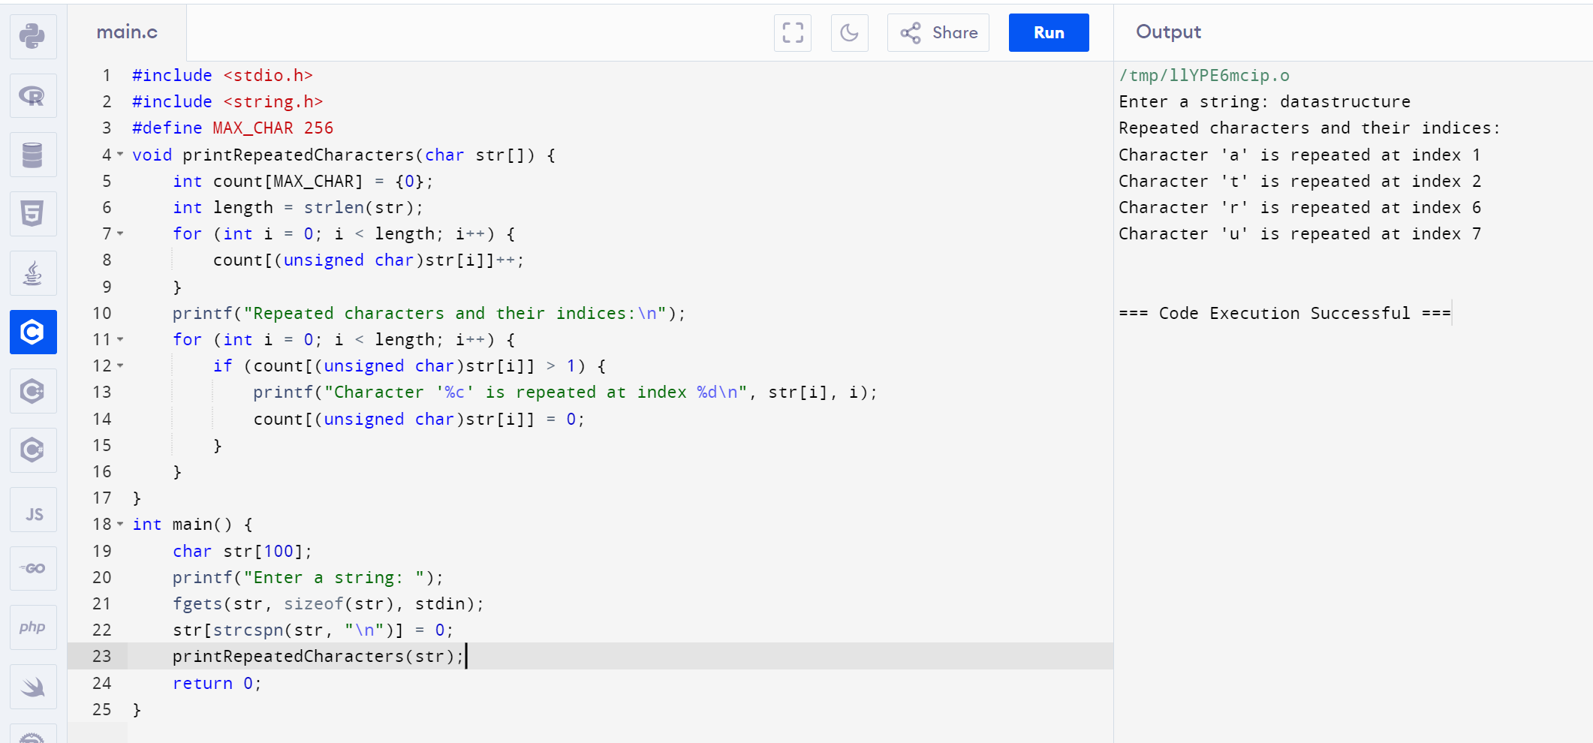

25. Implement a C Program for given set of Array elements - display 5th iterated element

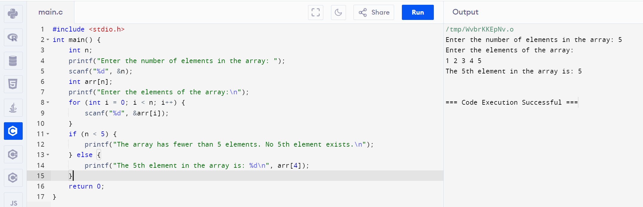

26. . Implement a C Program to perform Palindrome using SLL

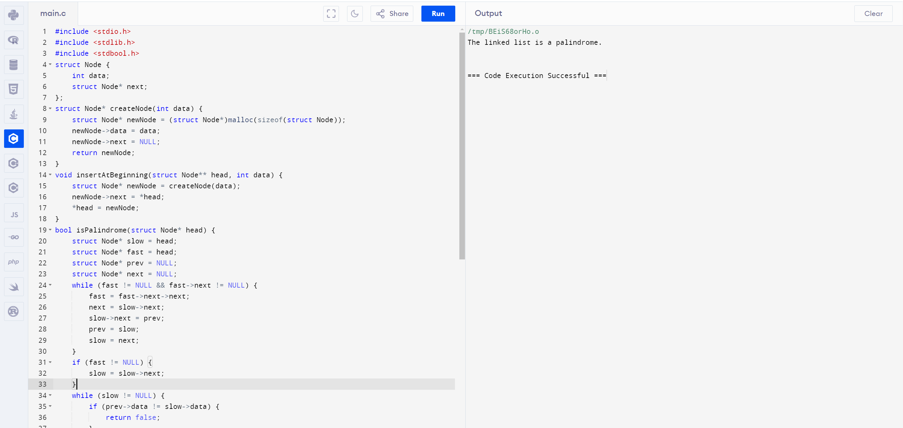

27. Implement a C Program for Given unsorted array - Display missing element

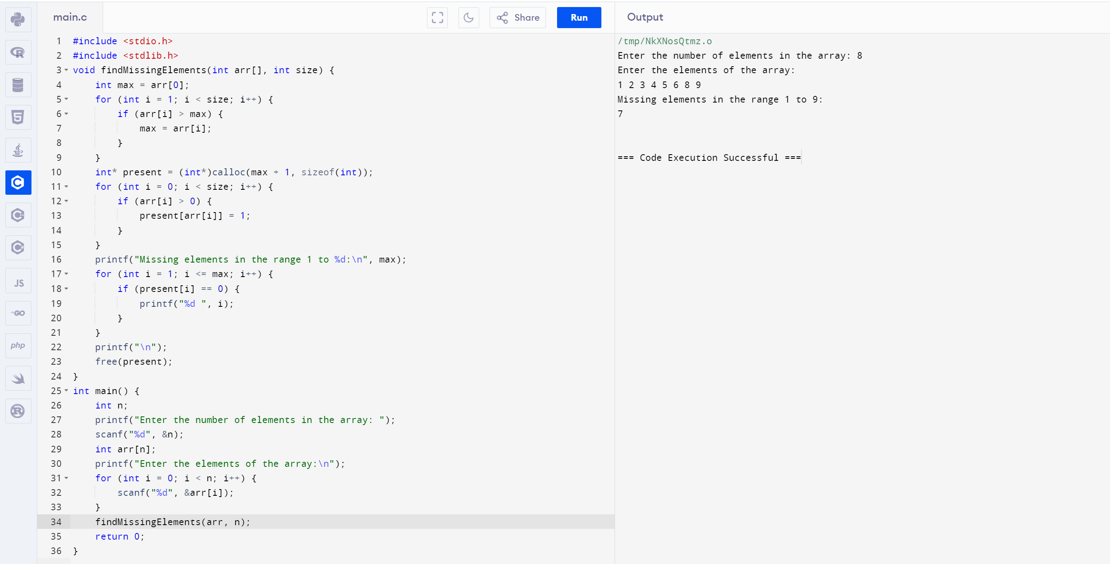

28. Implement a C Program for a Binary tree

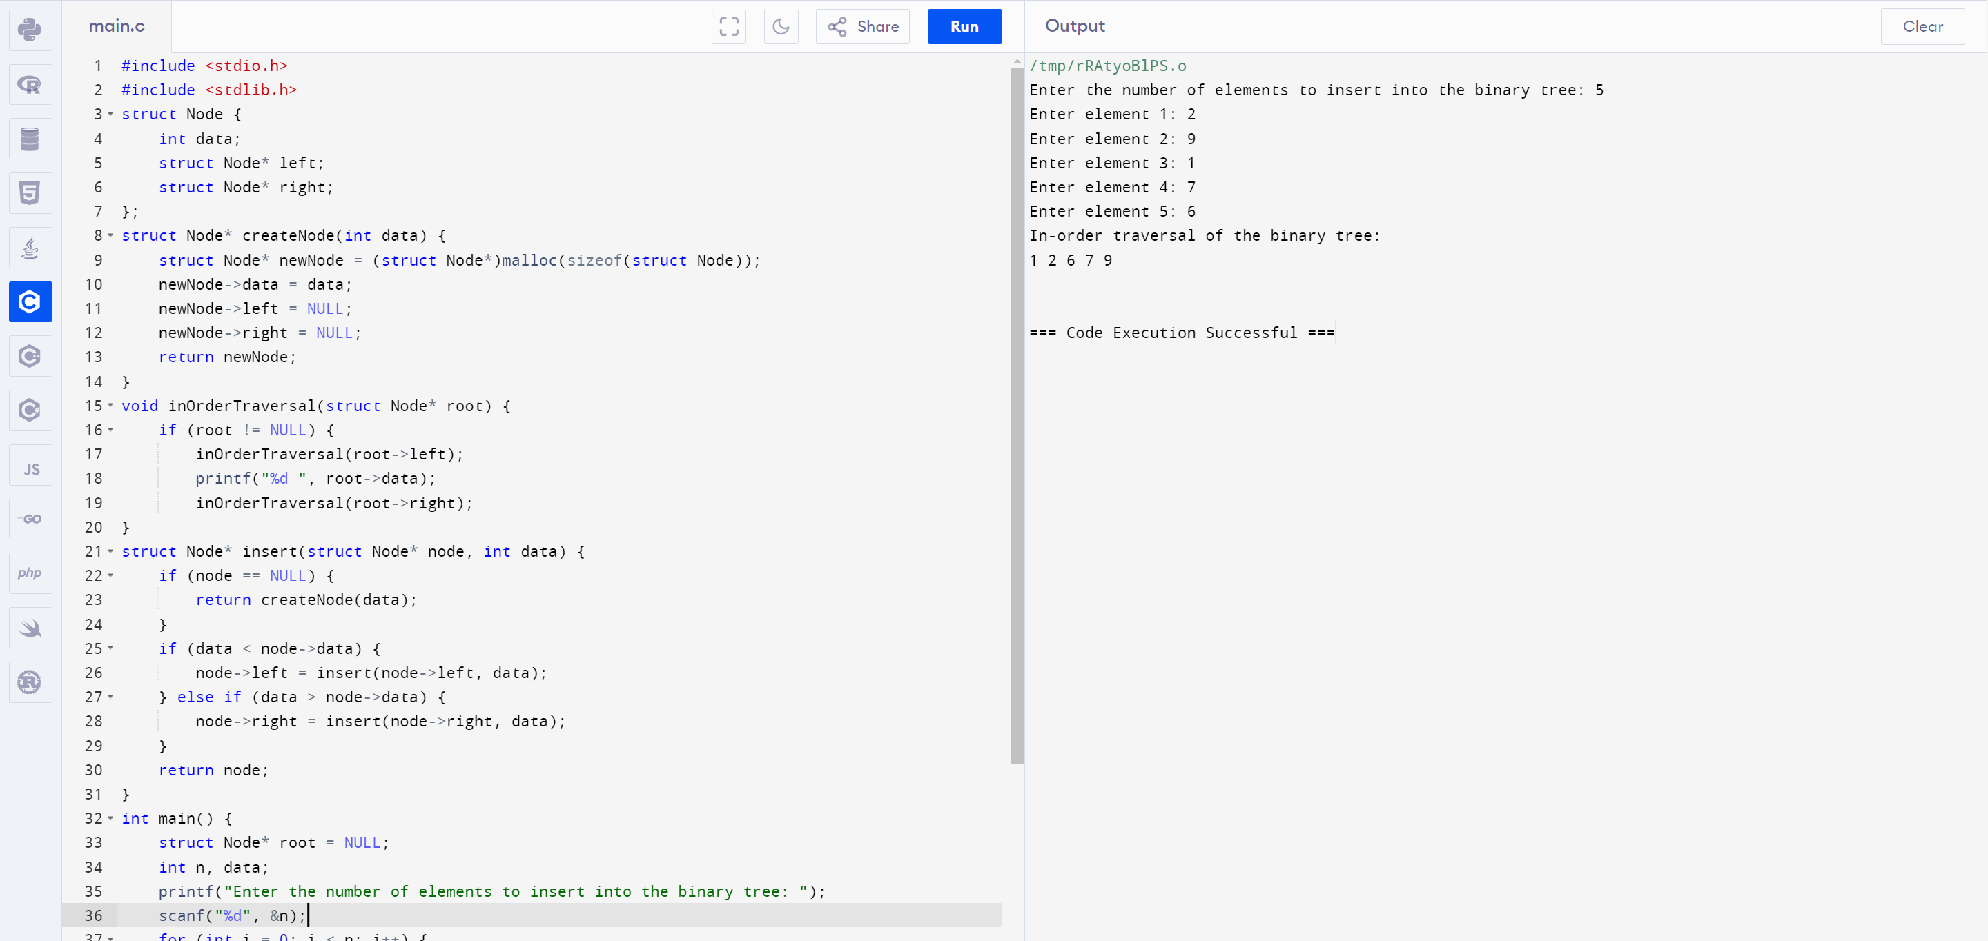

29. Implement a C Program for Array concatenation

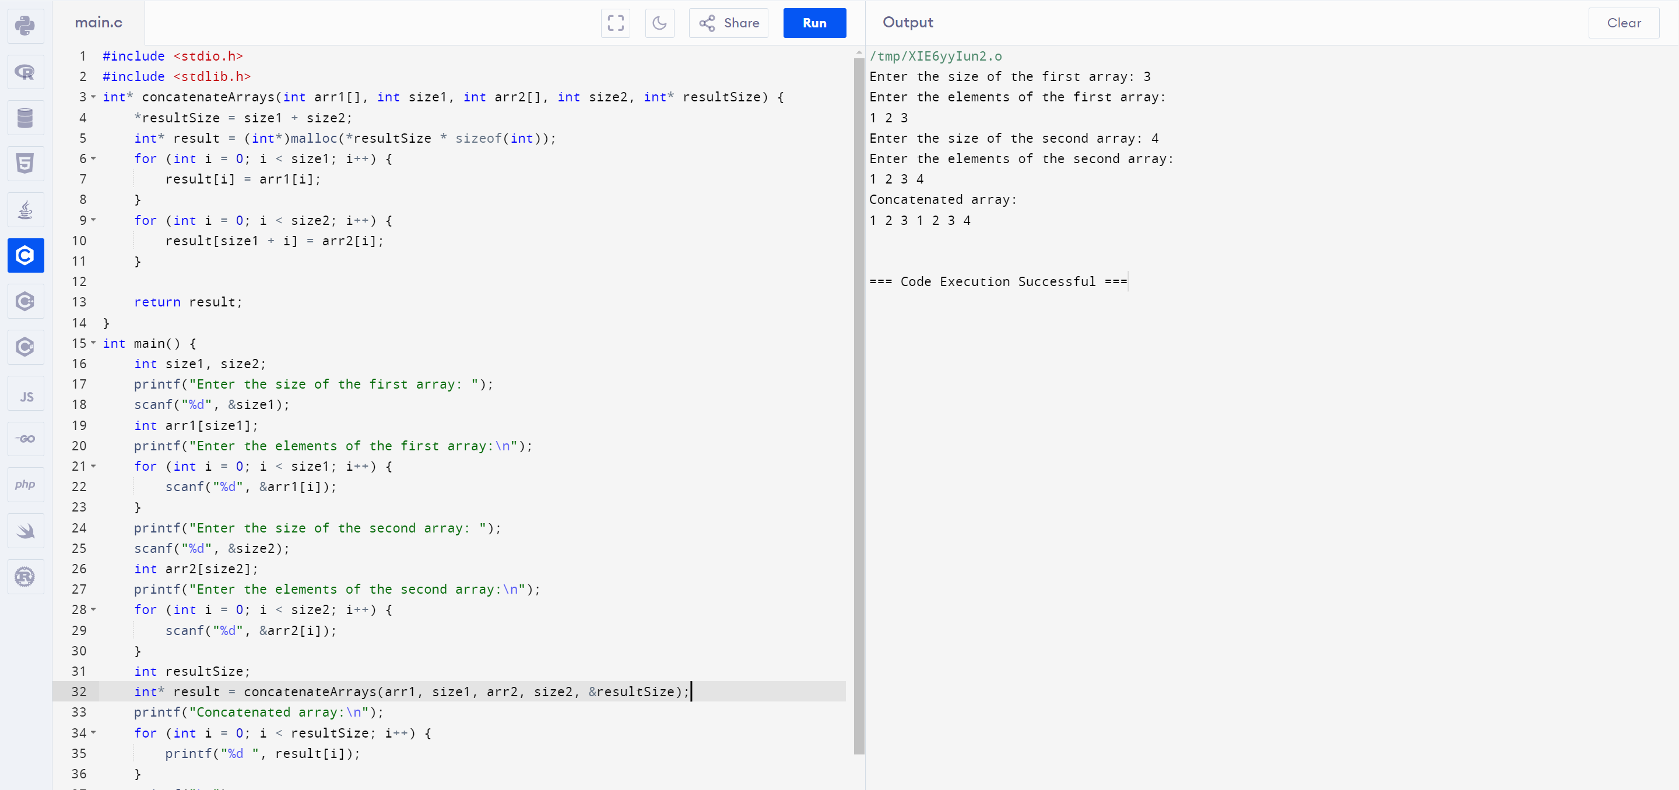

30. Implement a C Program to perform stack using two queues

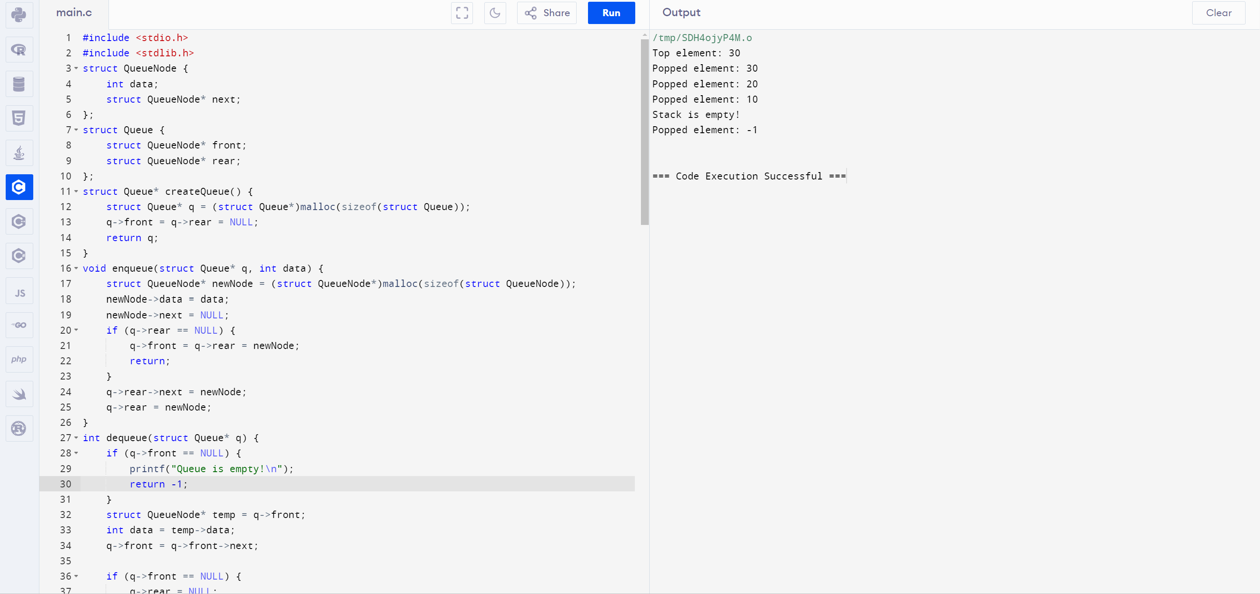

31. Implement a C Program to perform merge sort

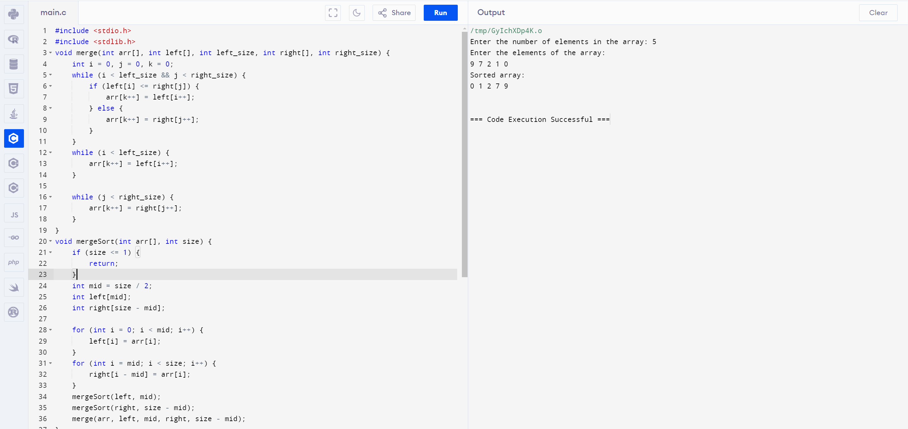

32. Implement a C Program to perform queue using two stacks

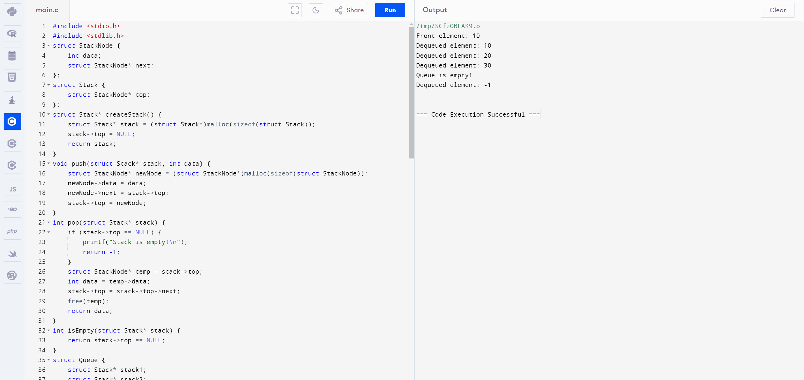

33. . Implement a C Program to perform insertion sort

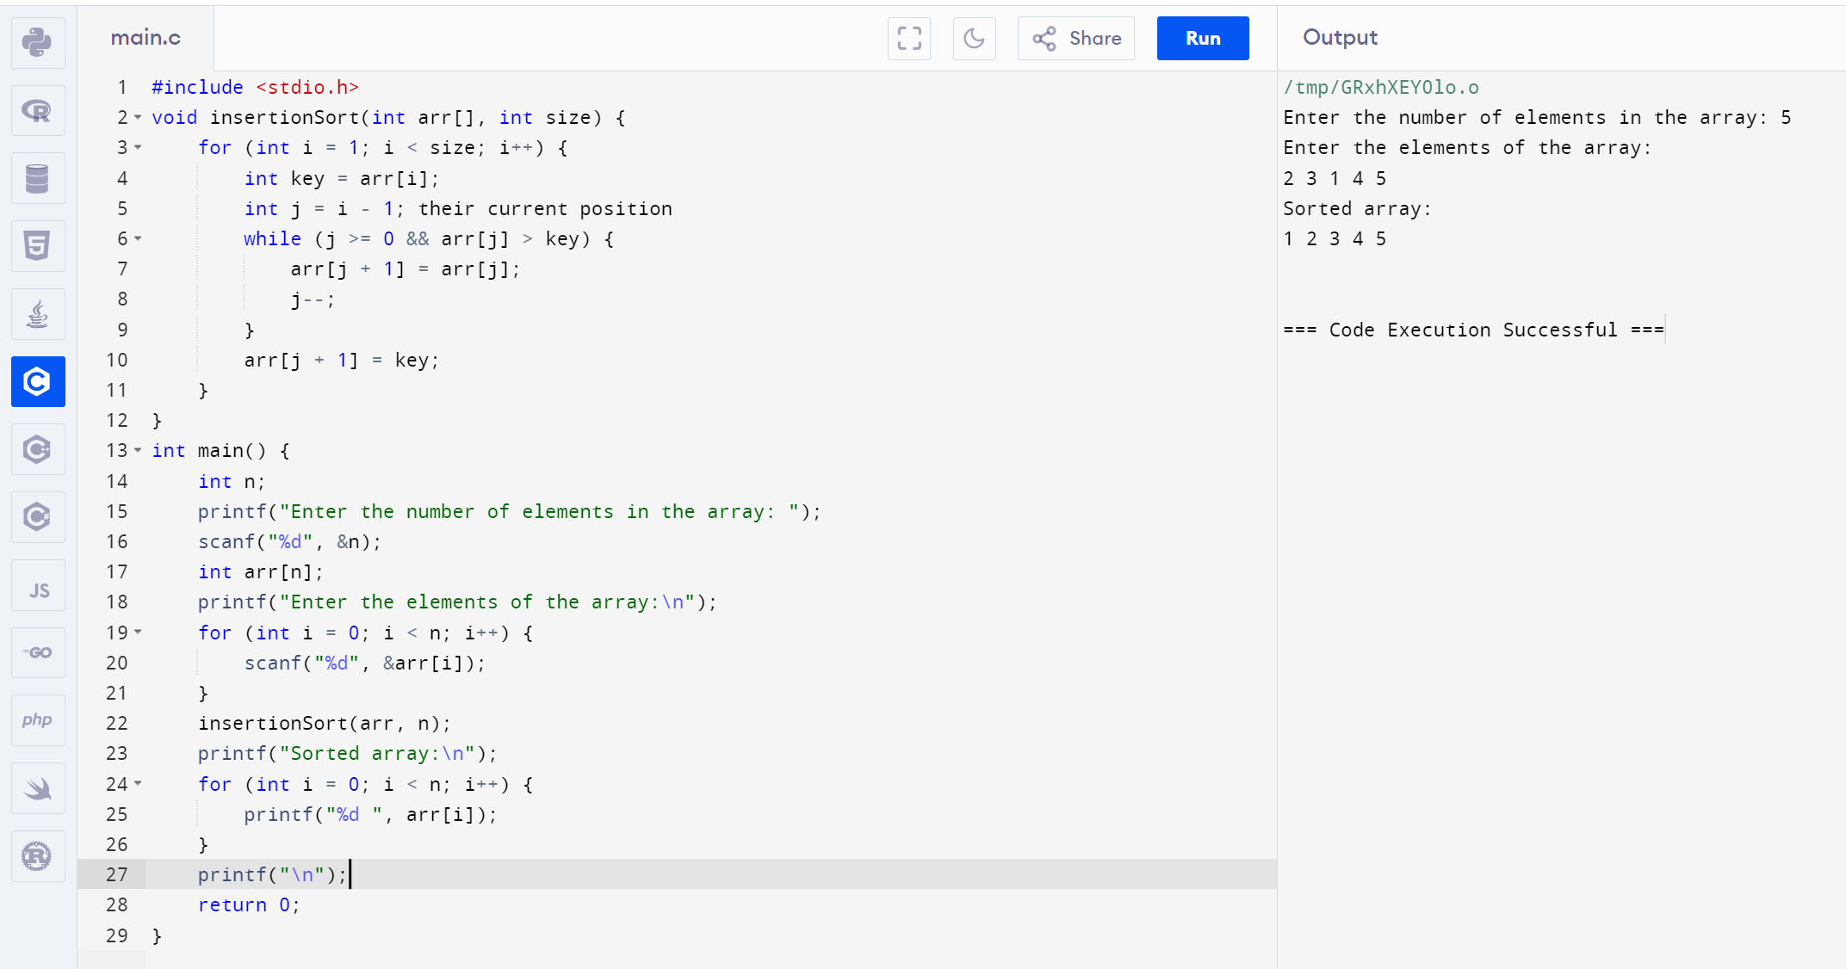

34. Implement a C Program to Intersect SLL

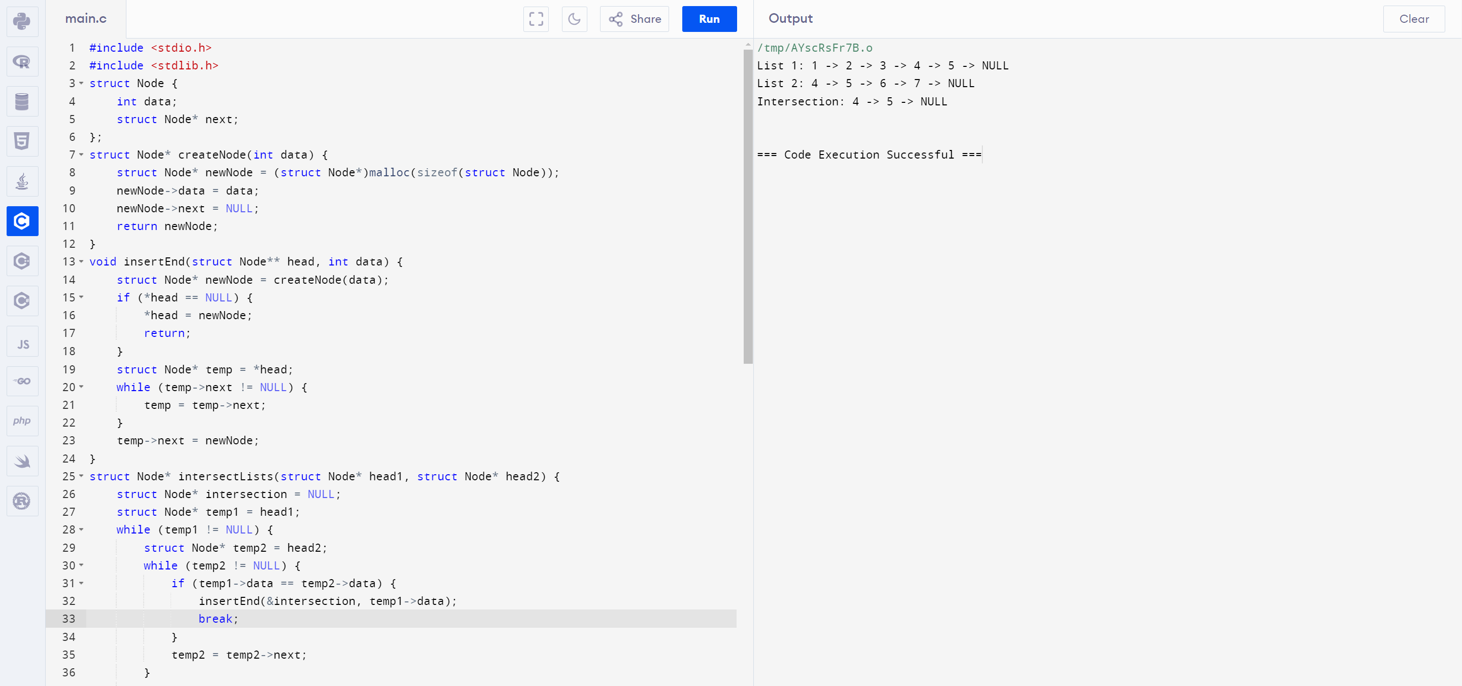

35. Write a program in C to merge two arrays of the same size sorted in descending order.

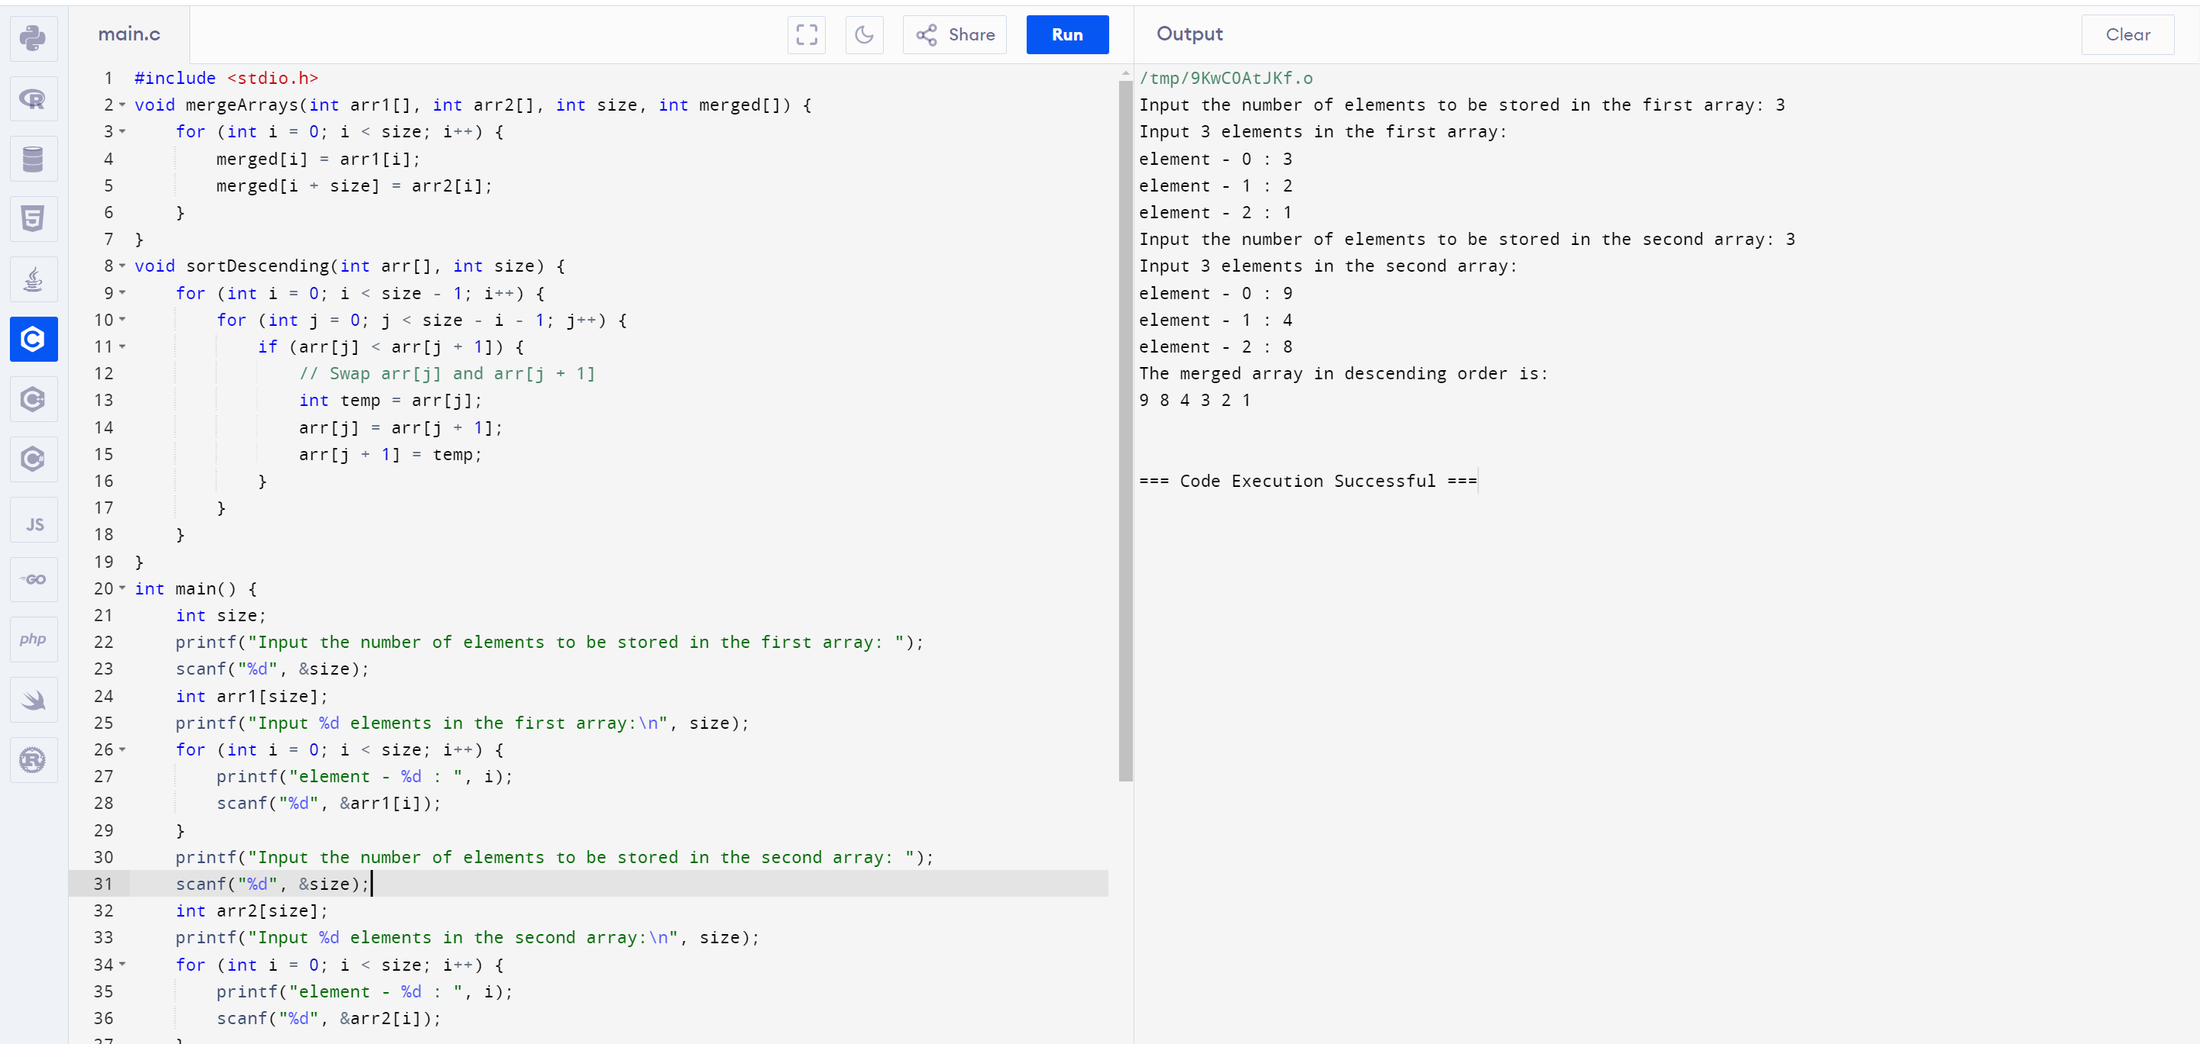

36. Implement a C Program to perform Tree traverse – Inorder, Prorder and Postorder

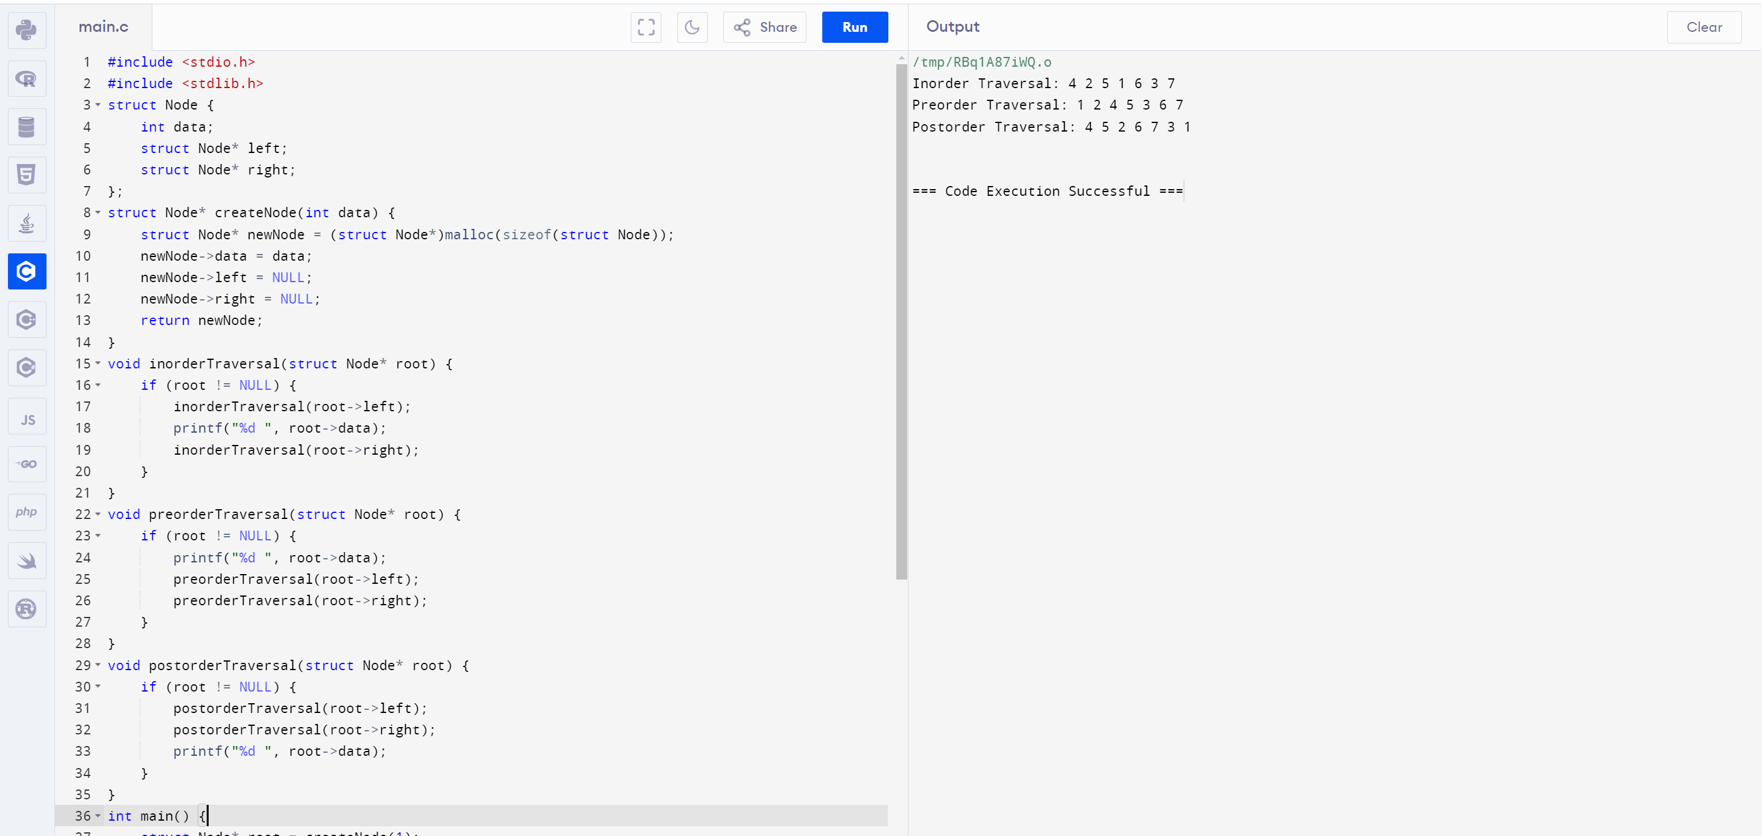

37. A Implement a C Program to perform search for unsorted elements

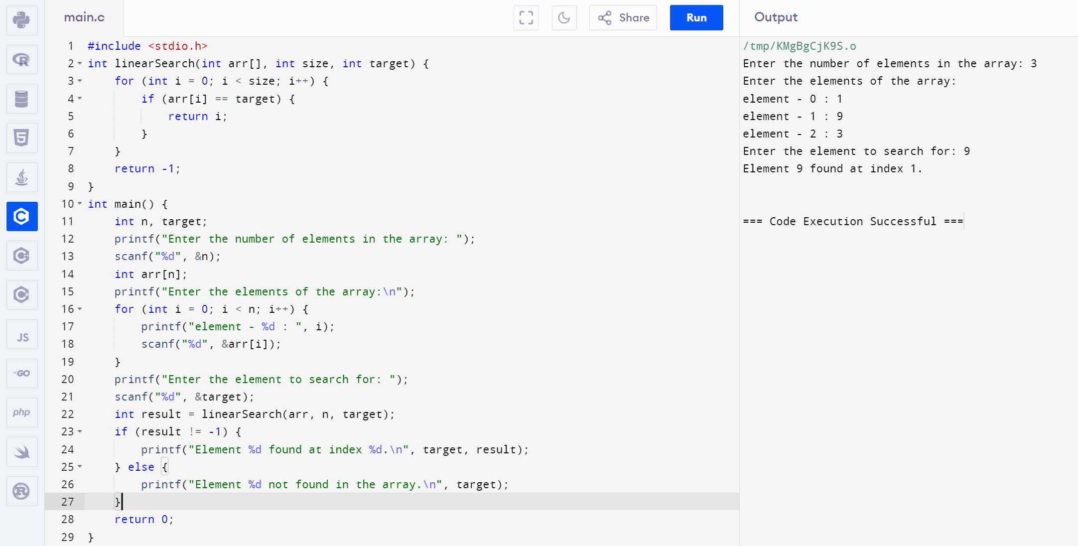

38. Implement a C Program for a Binary Search Tree - kth min value

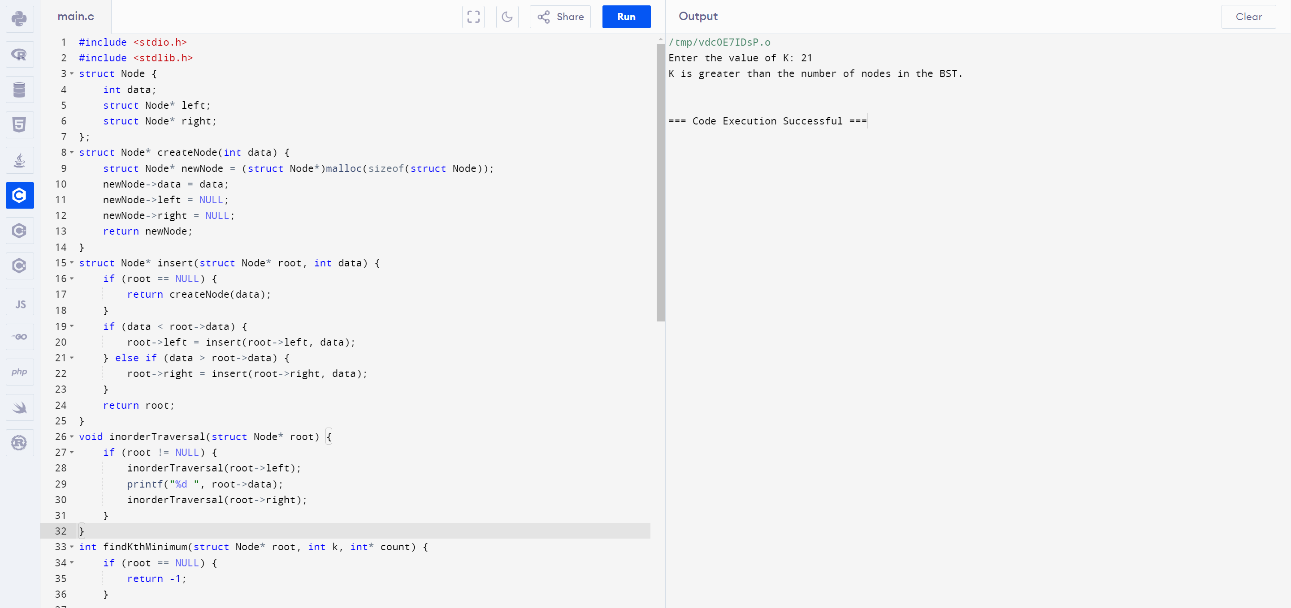

39. Implement a C Program for Given 2 D matrix to print largest element

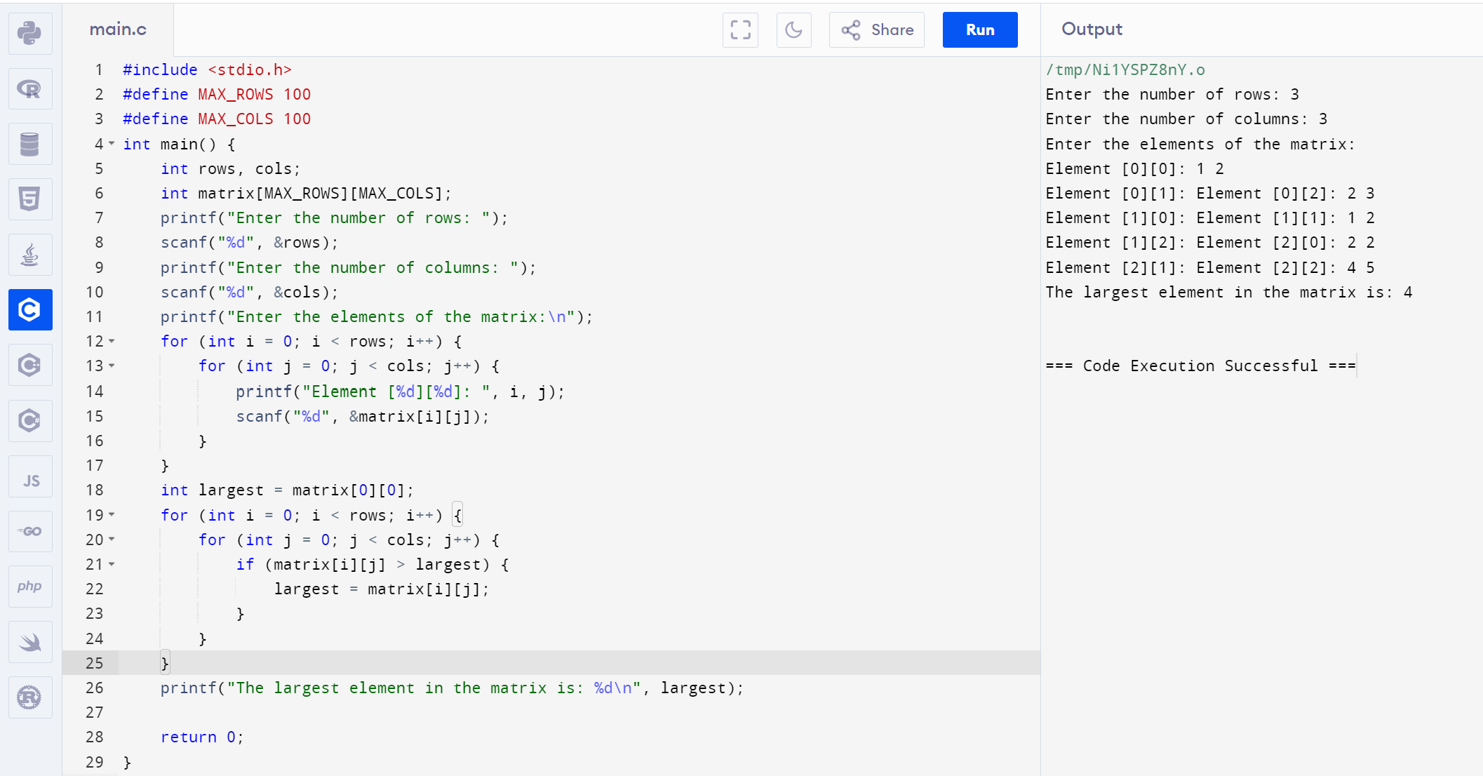

40. Implement a C Program to perform linked list – Insertion

